Continental Expands Cooling Fan Line for Popular
Can-Am and Polaris ATVs and UTVs
- Four new SKUs cover select Can-Am Outlander, Renegade, and Polaris RZR, Scrambler, Sportsman models
- Fans are engineered to withstand rugged, off-road conditions
Las Vegas, NV, November 4, 2024 – Continental, a leading aftermarket supplier of OE-engineered replacement parts, has just introduced four new part numbers to its line of rugged and durable Power Sport Fan Assemblies for direct replacement on popular ATVs (All-Terrain Vehicles) and UTVs (Utility Task Vehicles).
The new fans deliver coverage for Can-AM Outlander applications (2015-2020, 2018-2019) and Renegade applications (2016-2020, 2018). Polaris ATV coverage includes Sportsman applications (2012-2020) and Scrambler applications (2014-2019), while coverage for the Polaris RZR UTV includes model years 2018-2020. The fans are complete assemblies, with factory-style wiring connectors. No fan/motor assembly is required.
“Cooling fans are a critical part of the engine cooling system, but they have little protection from collision on many ATVs and UTVS,” notes Nathan Killeen, Continental Product Manager, who announced the expansion of the line. “As the popularity and demand for off-road recreation vehicles increases, the need for rugged and dependable replacement parts, like these cooling fans, becomes more important.
Continental Power Sports Fan Assemblies are engineered and built to perform in harsh conditions and in a variety of elements including extreme heat, cold, rain, and snow. Continental offers these fans for some of the most popular off-road applications to date and anticipates expanding the product line with part numbers in the near future.
Continental develops pioneering technologies and services for sustainable and connected mobility of people and their goods. Founded in 1871, the technology company offers safe, efficient, intelligent, and affordable solutions for vehicles, machines, traffic, and transportation. In 2023, Continental generated sales of €41.4 billion and currently employs around 200,000 people in 56 countries and markets.
Drawing on more than 120 years of cooperation with vehicle manufacturers, Continental offers a broad range of spare parts in OEM quality for the aftermarket. Under brands like Continental, ATE, VDO, REDI-Sensor, Autodiagnos, Uniroyal, Semperit, and GALFER, the technology company manufactures tens of thousands of products, including tires, brakes, drive components and thermal management components. It also provides diagnostic solutions, tools and services for repair shops. Continental is one of the most important suppliers in the independent automotive aftermarket.
Press contact

Anouré V. Fenstermaker
Head of Marketing Communications
Continental Automotive Aftermarket, North America
6755 Snowdrift Road, Allentown, PA 18106
Tel: 610-390-4000
Email: anoure.fenstermaker@continental.com

Image and caption

[Image: Continental-ATV-Fans.jpg]

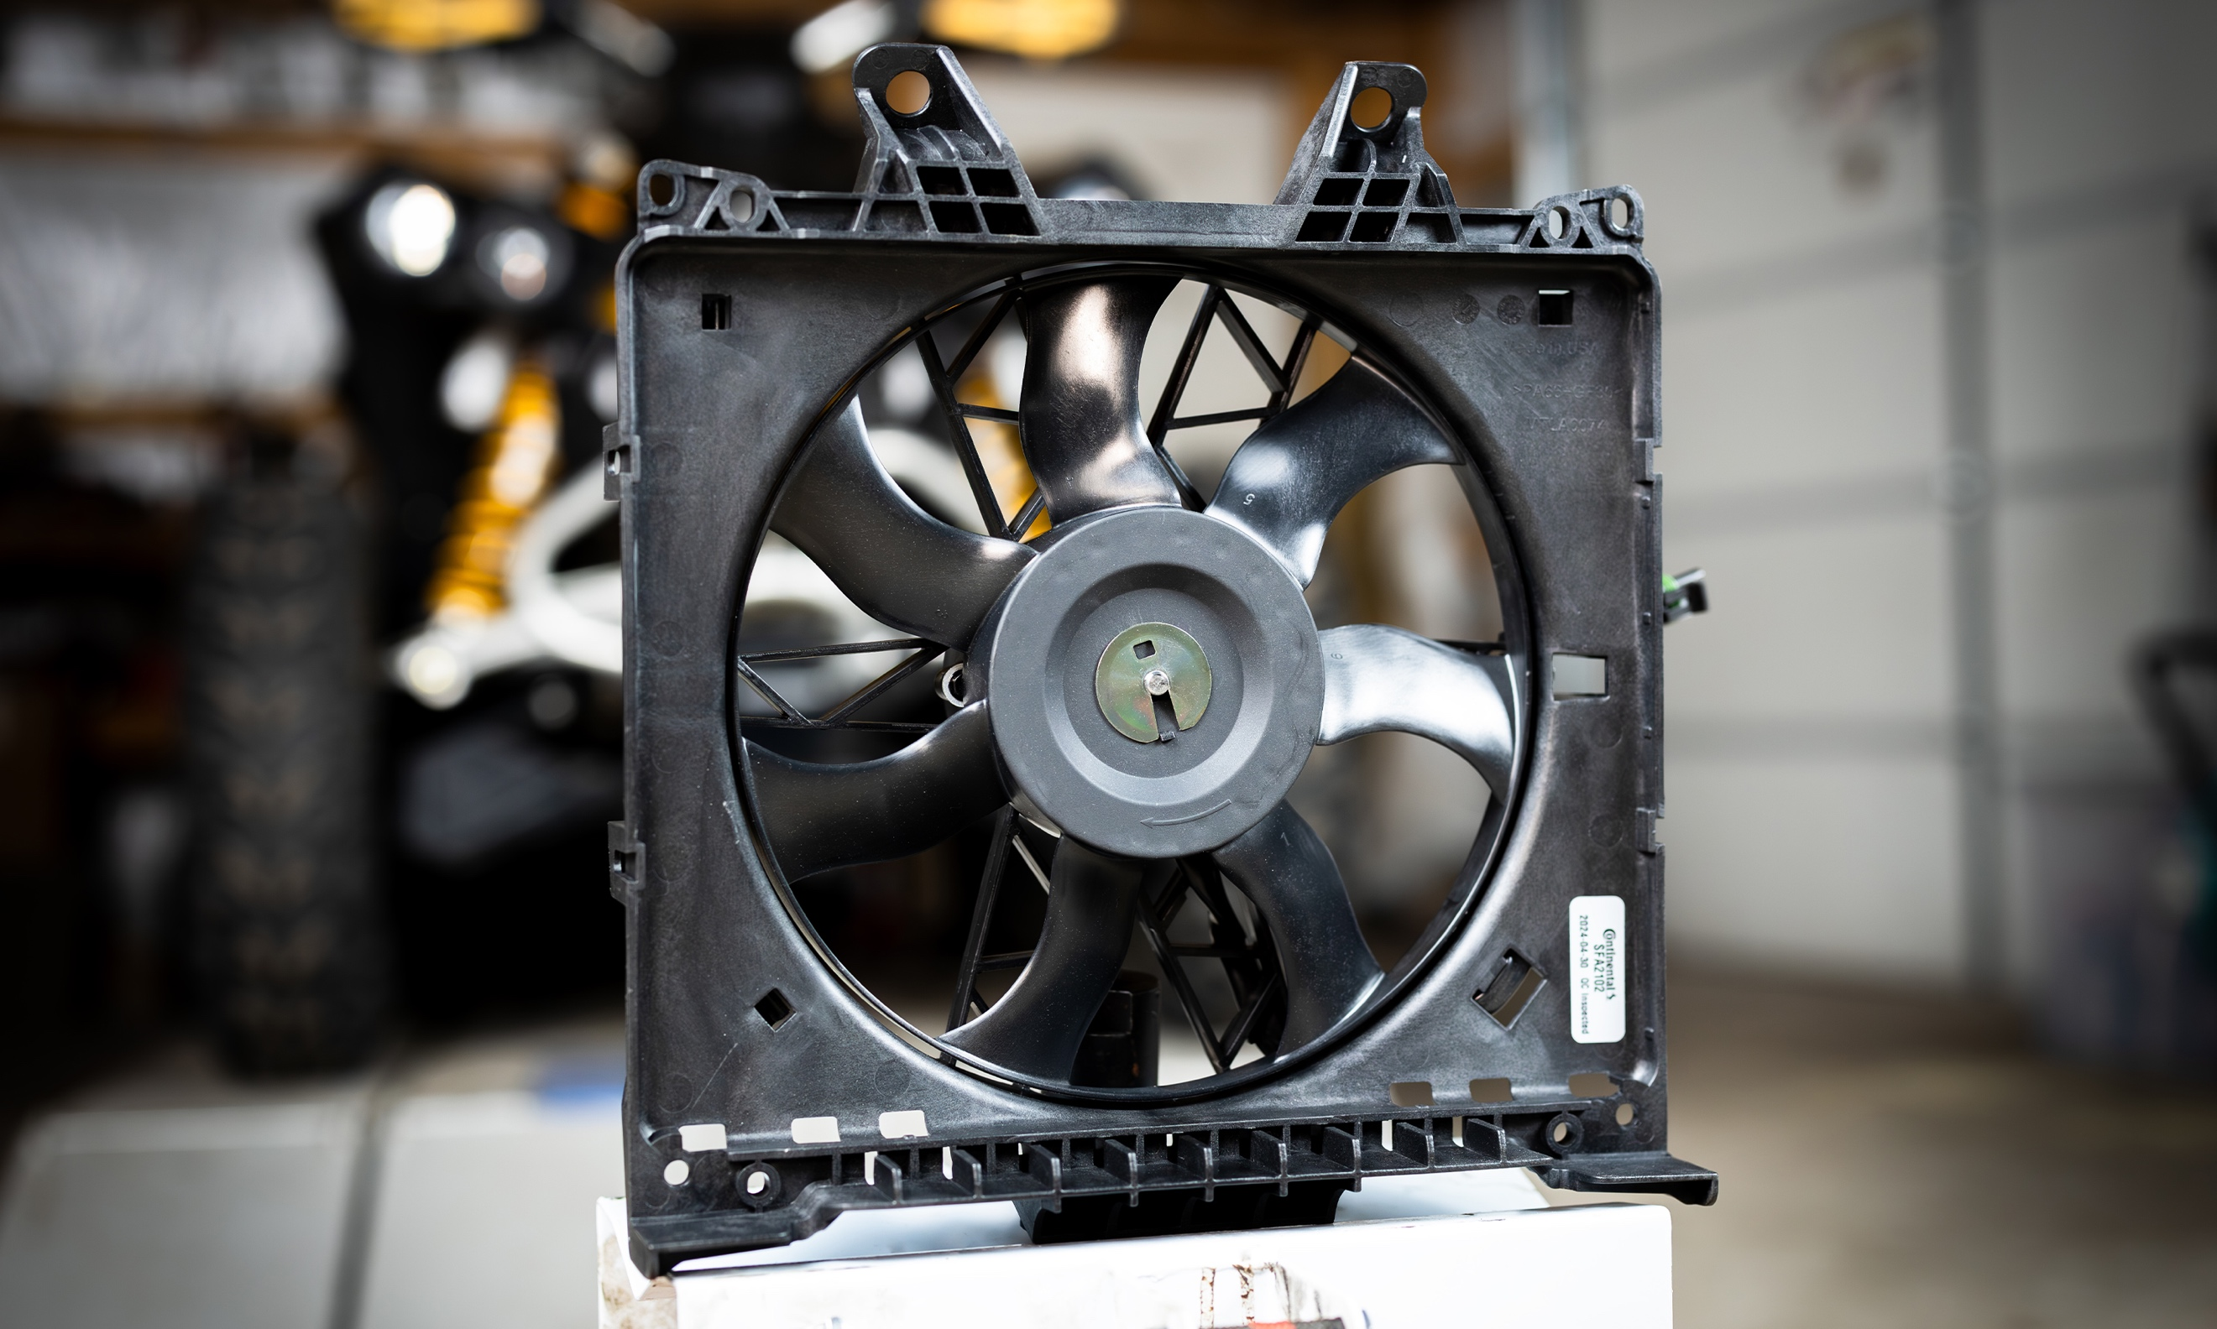

[Caption:]
Continental offers Power Sport Fan Assemblies for ATVs and UTVs

315-24/CO9041

