Continental Offers Two New Airbag Crash Sensors as Part of Growing Collision Portfolio
- Coverage includes Audi, Chevy, Chrysler, GMC, Honda, Hyundai, Kia, and VW models
- Seamlessly integrates with existing airbag control unit
- Sensors’ air bag applications include side-impact and all around collision detection
Las Vegas, NV., November 4, 2024 – Continental has introduced two new airbag crash sensors as a part of their growing collision parts portfolio aimed at offering shops aftermarket solutions to key safety technologies. The OE sensors offer coverage for popular Audi, Chevy, Chrysler, GMC, Honda, Hyundai, Kia, and VW models.

“These airbag crash sensors have been introduced to give shops and technicians more opportunities to provide service to their customers, as the safety technology in vehicles continues to evolve,” notes Nathan Killeen, Product Manager, Continental. “These are the sensors that trigger lifesaving restraint systems in just milliseconds.”

Continental offers two types of air bag sensors: Acceleration Satellite gSAT and Standard Pressure Satellite pSAT. The gSAT delivers all-around vehicle protection, measuring and supplying acceleration values in rigid vehicle structures to the airbag control unit. The pSAT sensor is specially designed to respond to side impact crashes, rapidly detecting the change in pressure within the doors of the vehicle, and sending alerts to the airbag control unit. The airbag crash sensors will be available in Q2 of 2025.
Continental develops pioneering technologies and services for sustainable and connected mobility of people and their goods. Founded in 1871, the technology company offers safe, efficient, intelligent, and affordable solutions for vehicles, machines, traffic, and transportation. In 2023, Continental generated sales of €41.4 billion and currently employs around 200,000 people in 56 countries and markets.
Drawing on more than 120 years of cooperation with vehicle manufacturers, Continental offers a broad range of spare parts in OEM quality for the aftermarket. Under brands like Continental, ATE, VDO, REDI-Sensor, Autodiagnos, Uniroyal, Semperit, and GALFER, the technology company manufactures tens of thousands of products, including tires, brakes, drive components and thermal management components. It also provides diagnostic solutions, tools and services for repair shops. Continental is one of the most important suppliers in the independent automotive aftermarket.
Press contact

Anouré V. Fenstermaker
Head of Marketing Communications
Continental Automotive Aftermarket, North America
6755 Snowdrift Road, Allentown, PA 18106
Tel: 610-390-4000
Email: anoure.fenstermaker@continental.com

Image and caption

[Image: Continental Air Bag Crash Sensor.jpeg]

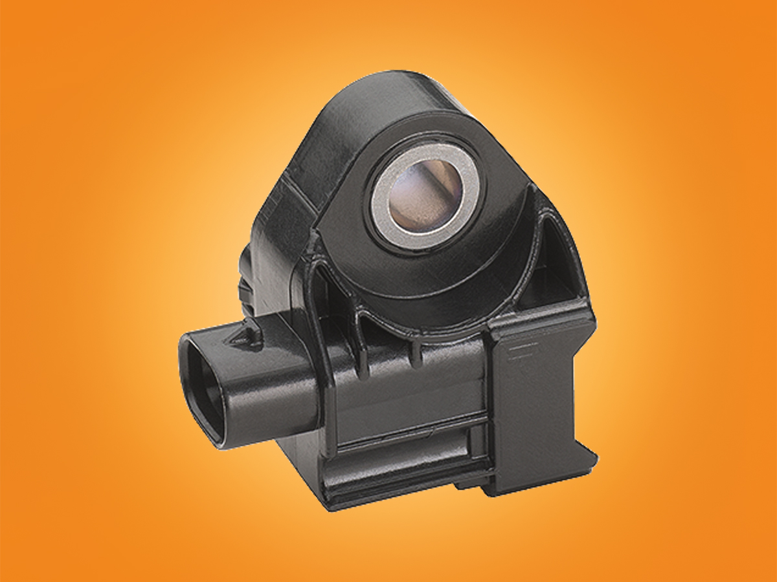

[Caption:]
Continental has introduced airbag crash sensors as a part of a growing ADAS portfolio.

